CHILDREN’S DANCE JOURNEY
2023

Your children’s dance journey is a progressive journey starting from the introductory age groups, where children attend with a parent/guardian to gain independence, physical literacy skills (putting them ahead of their peers by the time they start school) and confidence.

Once reaching the Dinky Dancers classes and beyond, we will aspire to inspire your child, help boost their confidence, self-esteem and creativity. Along the way they’ll build vital life skills such as resilience and courage and become important team players, learning to work with others. All achieved through a world of music and dance – not just tuition in a specific dance style. (The dance skills and genres we include are: Disco, Rock’n’Roll, Ballroom, Latin, Musical Theatre, Classical Sequence, with popular Ballet, Tap and Modern routines also being included at the younger age groups.)

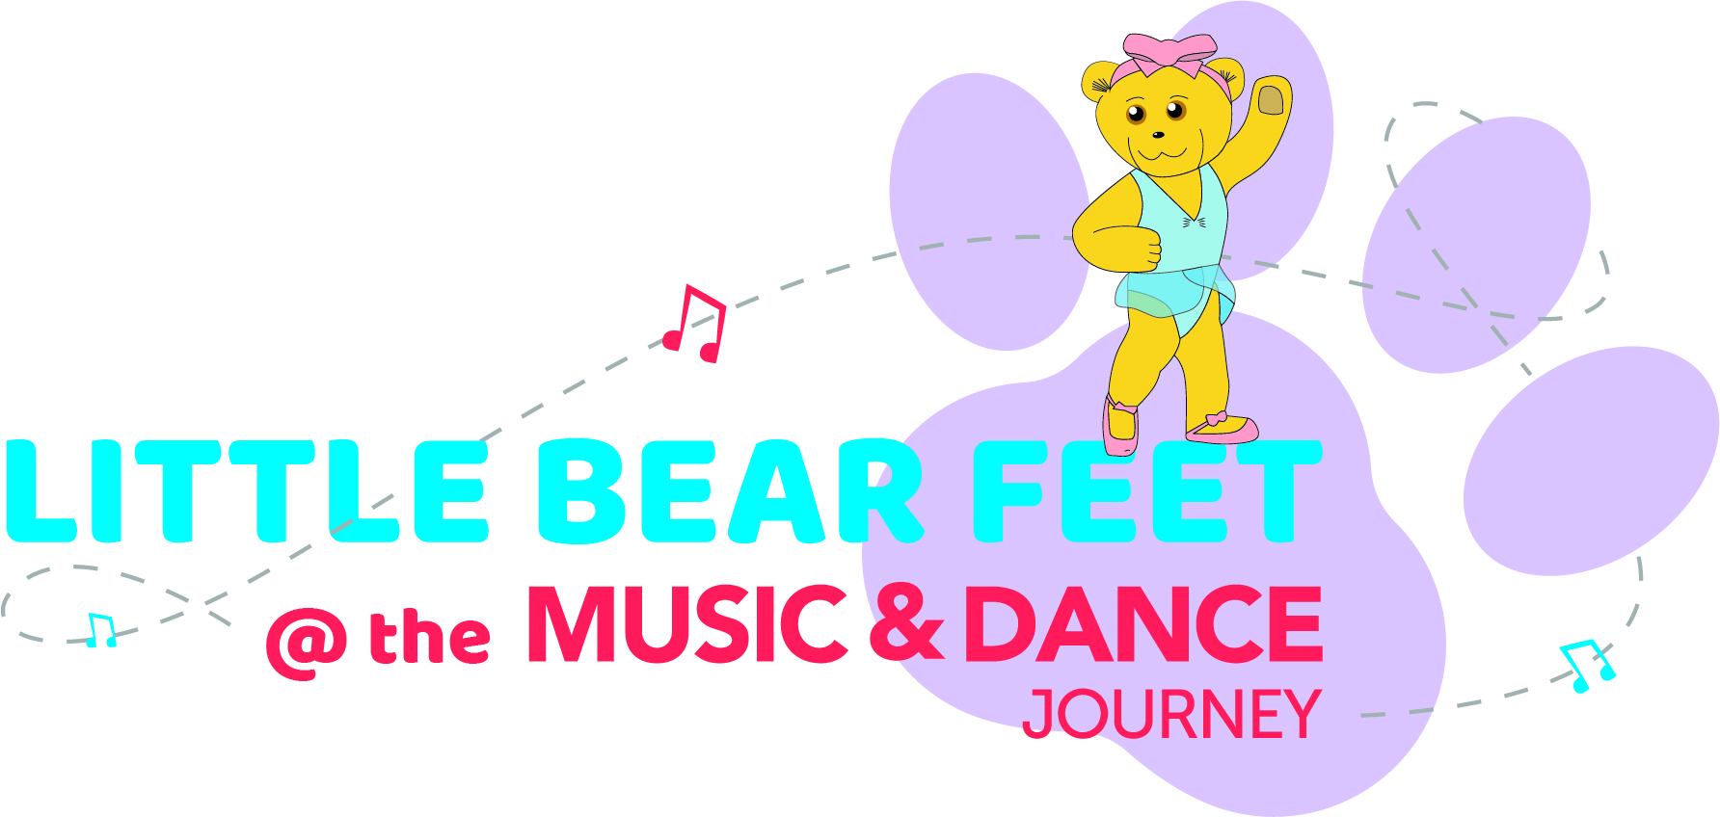 | Little Bear Feet (for children aged 18-30 months) + parent  Saturday 9.00-9.30am
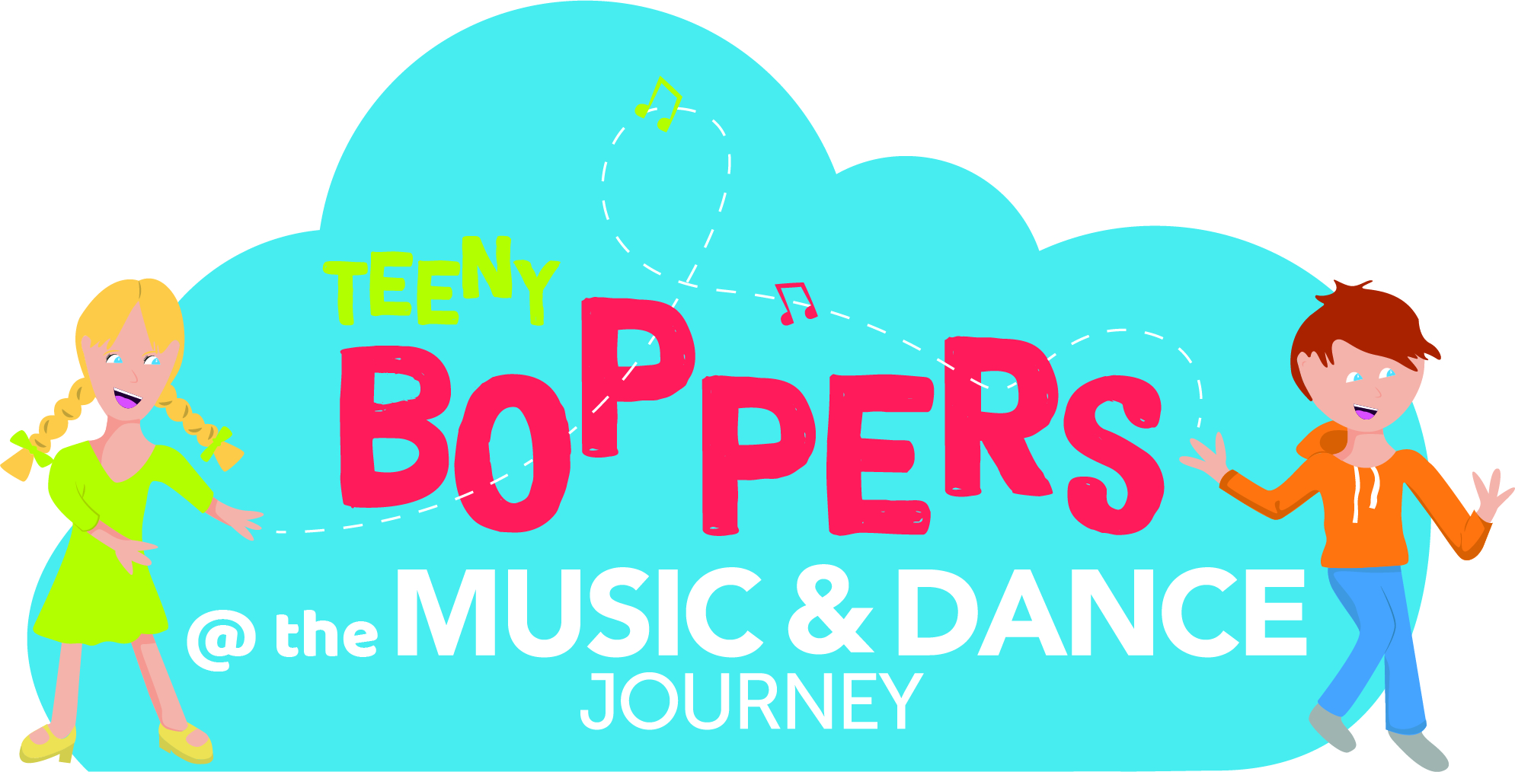 | Teeny Boppers (for children aged 2-4 years) + parent  Saturday: 9.45-10.15am for 2-3 year olds  Saturday 10.30 – 11.00 am for 3-5 year olds (register interest)
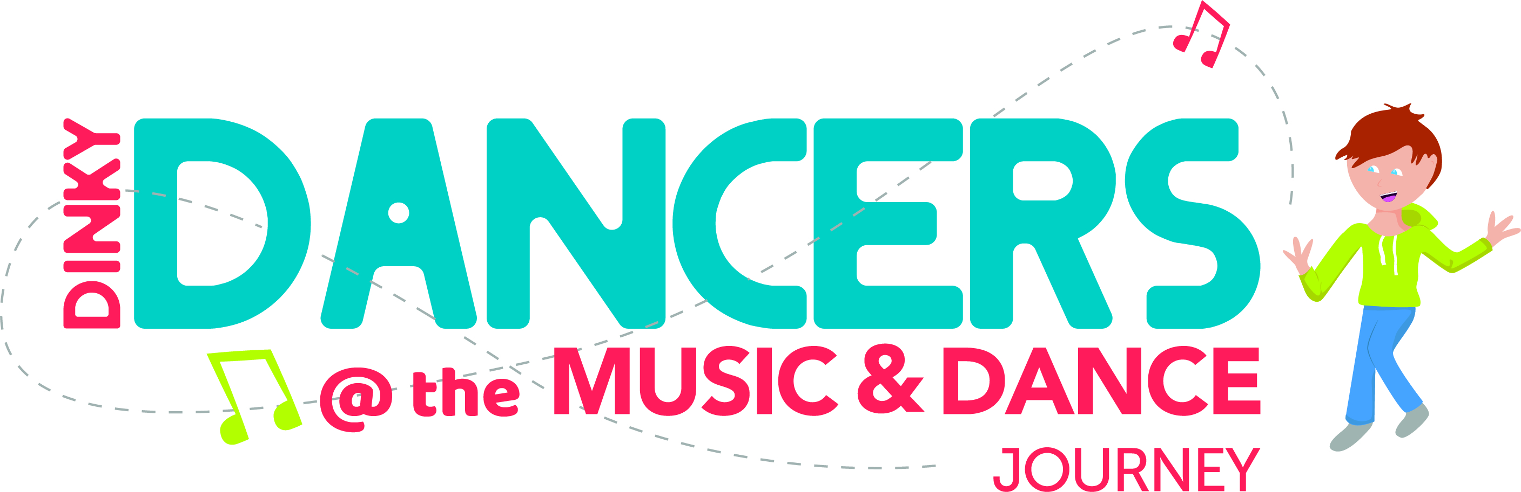 | Dinky Dancers (children aged 4-6 years) unaccompanied  This class will cover Rosette work  Saturday 11.15 – 12.00 noon (class full)
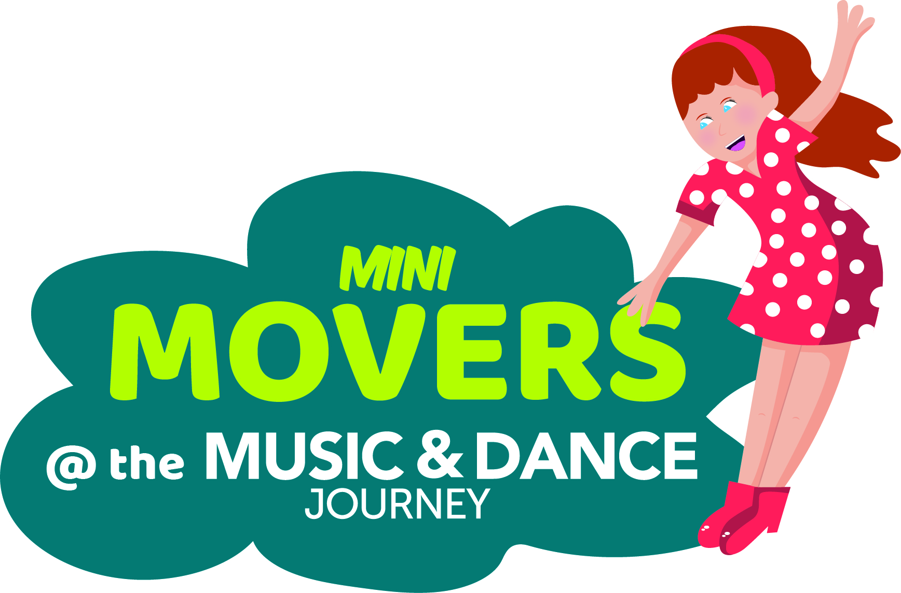 | Mini Movers (children aged 6-8 years) unaccompanied  This class will cover the Rosette or Star Dance work and introductory grades  Wednesday 4.30 – 5.15 pm (limited places)  Saturdays 12.15 – 1.00 pm (limited places)
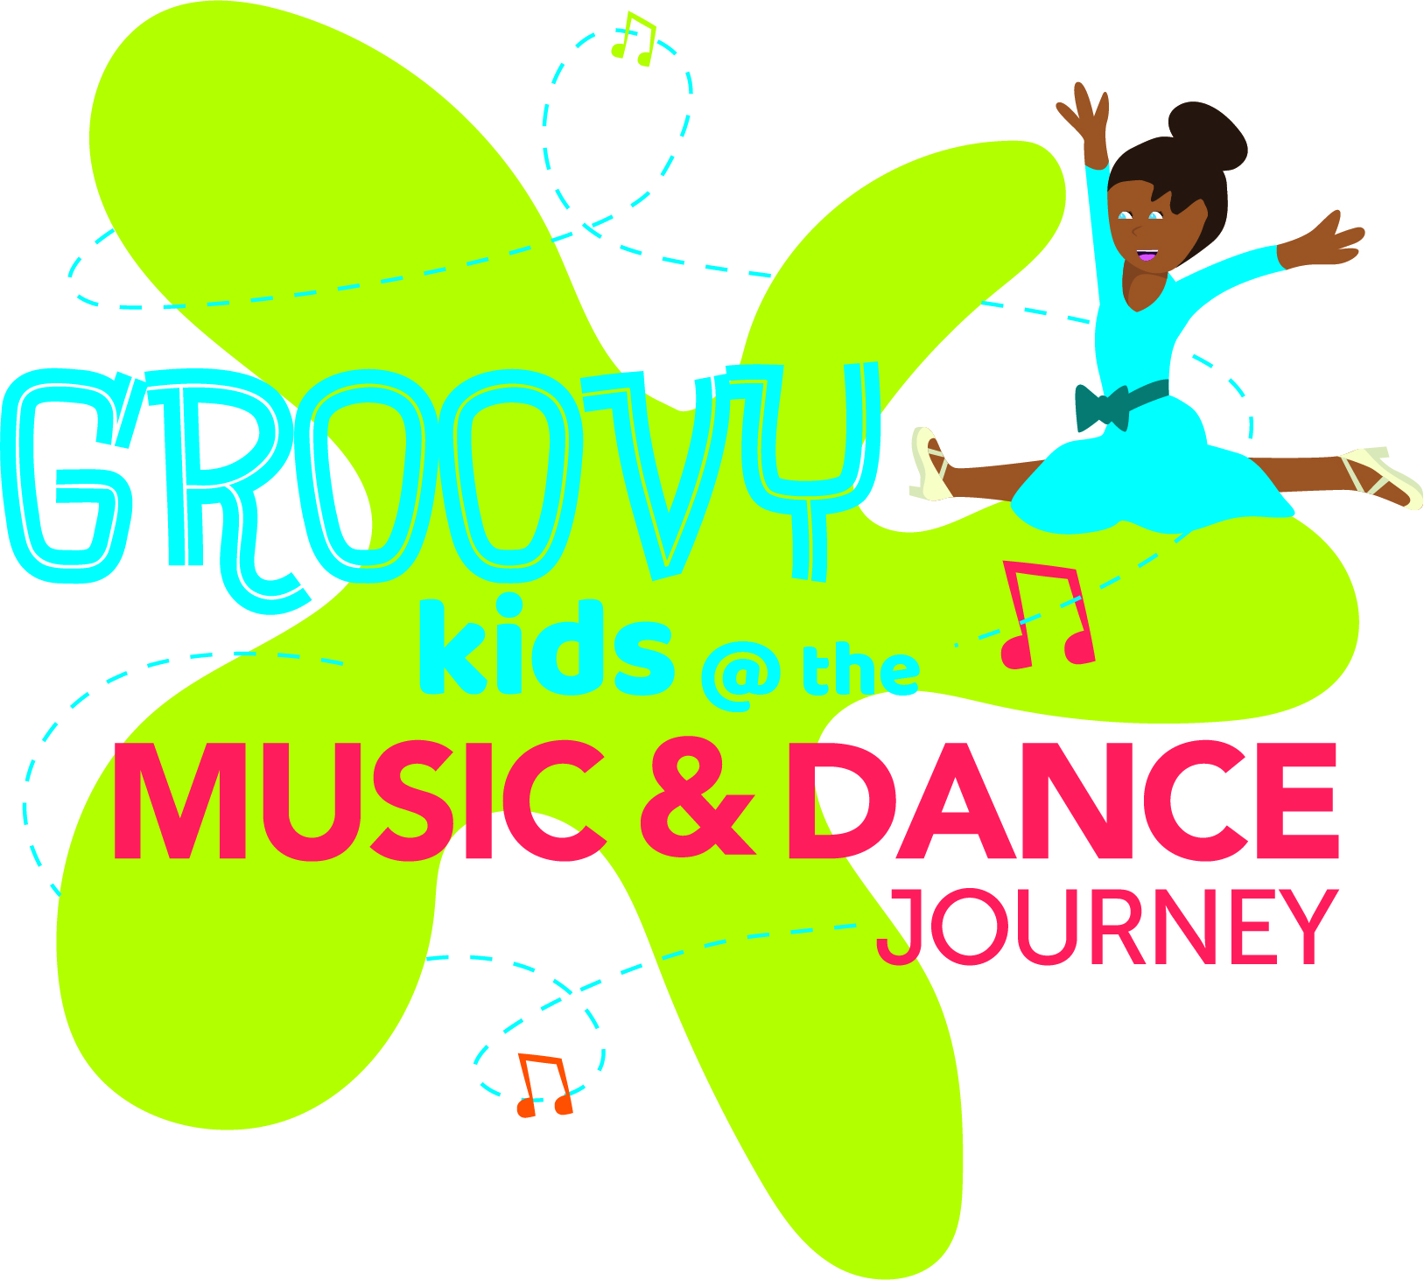 | Groovy Kids (children aged 8-13 years)  This class will complete Star Dance work and develop grade work  Wednesdays 5.25 – 6.10 pm  Fridays 5.30 – 7.00 pm (covers both Music & Dance)

